Merge M sorted Lists
Mark as Completed
0
Problem Statement: Given heads of k sorted linked lists as an array called heads, merge them into one single sorted linked list and return the head of that list.
Examples
Input : heads = [[head -> 1 -> 2 -> 3 -> 4], [head -> -4 -> -3], [head -> -5 -> -3 -> 1 -> 2 -> 3 -> 4]]
Output: head -> -5 -> -4 -> -3 -> -3 -> 1 -> 1 -> 2 -> 2 -> 3 -> 3 -> 4 -> 4
Explanation: head -> -5 -> -4 -> -3 -> -3 -> 1 -> 1 -> 2 -> 2 -> 3 -> 3 -> 4 -> 4
The nodes in bold come from the 3rd list, the underlined nodes come from the 2nd list, rest are from the 1st list.
Algorithm
Instead of extracting all values and sorting them again, we can merge the lists by always picking the smallest current node among all lists. This can be achieved efficiently using a min-heap (or priority queue), where we store the current node of each list and always extract the node with the smallest value. By pushing the next node of the extracted node back into the heap, we ensure that at any point, the heap contains the next smallest potential candidates. This approach avoids unnecessary sorting and leverages the fact that each list is already sorted.
- Create a min-heap that stores the current head node of each list.
- Push the head of each non-empty list into the min-heap.
- Initialize a dummy node to build the resulting merged list.
- While the heap is not empty:
  - Pop the node with the smallest value from the heap.
  - Append this node to the result list.
  - If the popped node has a next node, push it into the heap.
- Return the node next to the dummy as the head of the merged list.
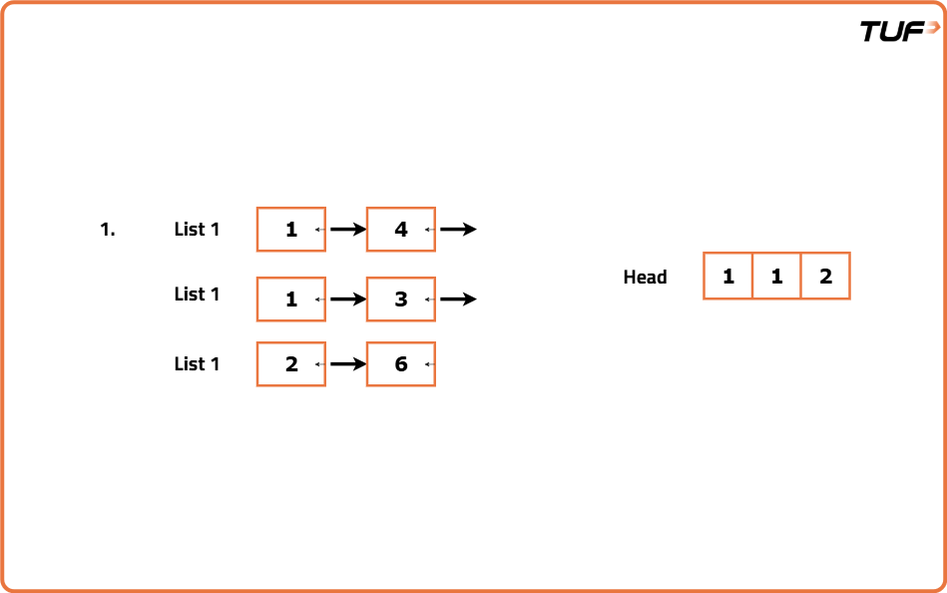
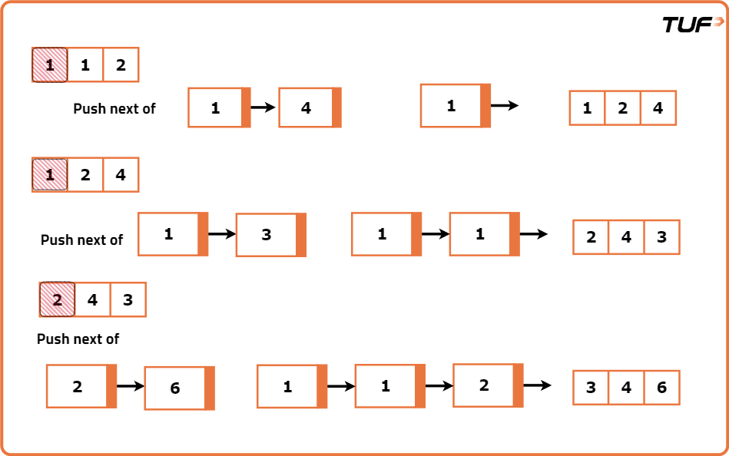
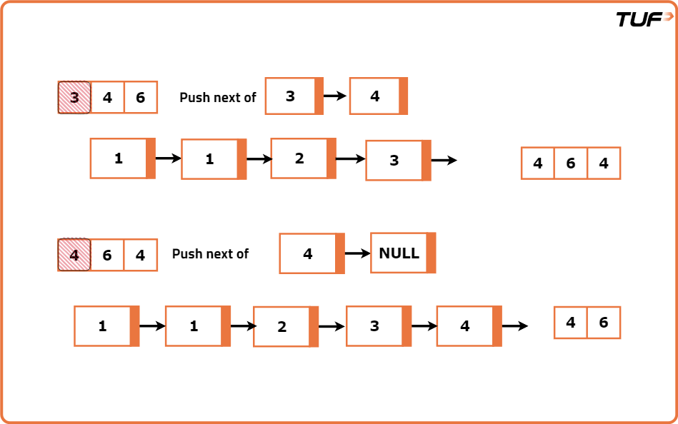
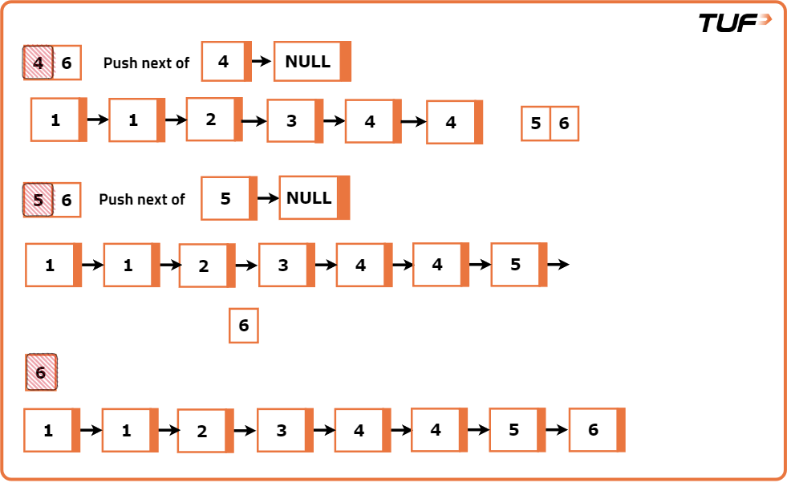
Code
import java.util.*;

// Definition for singly-linked list
class ListNode {
int val;
ListNode next;
ListNode(int x) {
val = x;
next = null;
}
}

class Solution {
// Function to merge k sorted linked lists using a min-heap
public ListNode mergeKLists(ListNode[] lists) {
// Create a priority queue (min-heap) to store nodes
PriorityQueue<ListNode> pq = new PriorityQueue<>(
(a, b) -> a.val - b.val
);

// Push the head of each non-null list into the heap
for (ListNode node : lists) {
if (node != null) pq.add(node);
}

// Create a dummy node to build the result list
ListNode dummy = new ListNode(0);
ListNode tail = dummy;

// While the heap is not empty
while (!pq.isEmpty()) {
// Extract the node with the smallest value
ListNode smallest = pq.poll();

// Add it to the result list
tail.next = smallest;
tail = tail.next;

// If there's a next node, push it into the heap
if (smallest.next != null) {
pq.add(smallest.next);
}
}

// Return the head of the merged list
return dummy.next;
}
}
Complexity Analysis

Time Complexity:O(N * log K) ,Where N is the total number of nodes across all K linked lists. Each insertion and extraction operation on the min-heap takes O(log K) time, and we perform such operations N times (once per node). Hence, the overall time complexity becomes O(N * log K).
Space Complexity:O(K),The heap stores at most K nodes at any time one from each of the K linked lists. Therefore, the auxiliary space used by the priority queue is O(K). The final merged linked list uses O(1) extra space if we disregard the output list, as the nodes are rearranged rather than copied.

